The Haunted Mansion

Assessment Type  Knowing and Understanding | Recommended Grade Level  Grade 6 (MYP1) | MYP Criterion Level  MYP 1

MYP Assessment Criteria  Criterion A: Knowing and understanding |  | MYP Command Terms Used  select, apply, find, write down, show, use, plot, label, describe, draw, determine, solve
MYP Global Context
Identities and relationships
MYP Key Concept  Relationships | MYP Related Concepts  Quantity, Simplification

MYP Branch of Mathematics
Numerical and abstract reasoning
MYP Topics and Skills  - Number operations  - Order of operations and expanding brackets  - Points on the coordinate plane  - Basic reflections (over the $x$- and $y$-axis) | Prior Knowledge Needed  - Applying the four basic mathematical operations (addition, subtraction, multiplication, division) on positive and negative numbers  - Plotting points and finding coordinates of points  - Reflect points over the $x$- and $y$-axis

Assessment Description

In this assessment, students select and apply the appropriate mathematical method to find the value of expressions, using the correct order of operations. Additionally, students are asked to plot points on a coordinate plane, given their coordinates, and find the coordinates of points shown on a graph. Furthermore, students are asked to reflect points over the $x$-axis and the $y$-axis, and then find the coordinates of the point of reflection.

Materials Needed

Pen, pencil (for points and lines), ruler (required for drawing)

Task-specific instructions / Recommendations

The use of a calculator is not allowed for this assessment task.

Assessment Criterion A: Knowing and understanding

 | Achievement Level Descriptor  (MYP1) | Task Specific Descriptor
0 | The student does not reach a standard described by any of the descriptors below.
1-2 | The student is able to:  - select appropriate mathematics when solving simple problems in familiar situations  - apply the selected mathematics successfully when solving these problems  - generally solve these problems correctly in a variety of contexts. | The student is able to:  - select the appropriate method to find the value of the three missing symbols in question (1)  - apply the selected method successfully when finding the value of the three missing symbols in question (1)  - find the value of the three missing symbols and list these values in ascending order in question (1)
3-4 | The student is able to:  - select appropriate mathematics when solving more complex problems in familiar situations  - apply the selected mathematics successfully when solving these problems  - generally solve these problems correctly in a variety of contexts. | The student is able to:  - select the appropriate method to find the value of the six symbols in question (2)  - apply the selected method successfully when finding the value of the six symbols in question (2)  - find the value of the six symbols, write down their final answers at the bottom of each box, write down the location of the friends in question (2), and plot and label the required locations in question (3)
5-6 | The student is able to:  - select appropriate mathematics when solving challenging problems in familiar situations  - apply the selected mathematics successfully when solving these problems  - generally solve these problems correctly in a variety of contexts. | The student is able to:  - select the correct number for each blank space in question (4)  - plot and label the required locations in questions (4) and (6) and describe the movement in question (5)  - draw the moves described in questions (4) and (5), and select the correct description in question (6)
7-8 | The student is able to:  - select appropriate mathematics when solving challenging problems in both familiar and unfamiliar situations  - apply the selected mathematics successfully when solving these problems  - generally solve these problems correctly in a variety of contexts. | The student is able to:  - determine the required reflection correctly, write down their choice in question (8), and select the appropriate method in question (9)  - describe the movement in questions (7), (8), and (9), apply the selected method in question (9), and plot and label the required points in questions (8) and (9)  - draw the moves described in questions (7) and (8),  and write down the coordinates of the starting and ending points in question (8)

The Great Trap
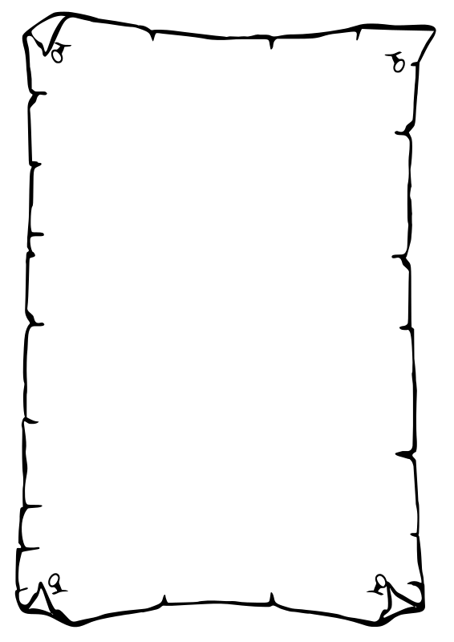
You and your friends foolishly enter a haunted mansion, seeking adventure. As the doors shut behind you, a trap door is released below you, and you fall through it. Can you escape and return to your friends using your mathematical ability to outwit the mansion? Let’s find out!

In the basement where you find yourself, you notice some writings on the wall:

To find the passcode to escape the basement, you must do the following:

The symbols we know:
$$⊕$$ | $$=$$ | $$-4$$ |  | $$△$$ | $$=$$ | $$8$$
$$⊖$$ | $$=$$ | $$5$$ |  | $$⊙$$ | $$=$$ | $$-3.5$$
The relationships we know:

$∎=△-⊖$ and $⋕=∎×\left(△+⊕\right)$ and $⊞=2×⊙-\left(⊕-⊖\right)$

- Select and apply the appropriate method to find the value of the three missing symbols: $∎$, $⋕$, $⊞$.
Show your work below.

Write down each value in the box below to open the secret door to escape the basement.

The value of $∎$: |  | The value of $⋕$: |  | The value of $⊞$:

Now that we have the value of each of the seven symbols ($⊕$, $⊖$, $△$, $⊙$, $∎$, $⋕$, and $⊞$), list these values in ascending order:

[A: 1-2, i-iii]

Locating Your Friends

As you escape the basement through the secret door, you find a map on the floor. When you take a closer look, you’re shocked to realize that the map seems to show the location of your friends in some coded way. To decode, you need to do some work.
- (a) Select and apply the appropriate method to find the value of each of the six symbols.
(b) Show your work in the boxes.
(c) Write down the final answer at the bottom of each box in the space provided.

$$15+\left(-9\right)×2=❤️$$ | $$\left(-36\right)÷\left(-6-12\right)=☘️$$
$$❤️=$$ | $$☘️=$$
$$4-\left(-5\right)×\left(-2\right)=🟣$$ | $$\left(-3\right)÷\left(4-7\right)=🟦$$
$$🟣=$$ | $$🟦=$$
$$\frac{-8+2×(2-5)}{-2}=🔶$$ | $${\left(2-6\right)}^{2}-\frac{22}{2}=🔆$$
$$🔶=$$ | $$🔆=$$

Then, use the values you found for the symbols above to write down the location of each of your friends:

- Andrew’s location is $\left(❤️,🔆\right)$, which is $\left(_____,_____\right)$

- Brigitte’s location is $\left(🟣,-🟦\right)$, which is $\left(_____,_____\right)$

- Christian’s location is $\left(-🔶,☘️\right)$, which is $\left(_____,_____\right)$

- Danielle’s location is $\left(☘️,-❤️\right)$, which is $\left(_____,_____\right)$
[A: 3-4, i-iii]

The map you found is shown below. According to the map, your location, as you exit the basement, is at the point $\left(1,-6\right)$.
- On the map below, plot and label your location and the location of each of your friends.
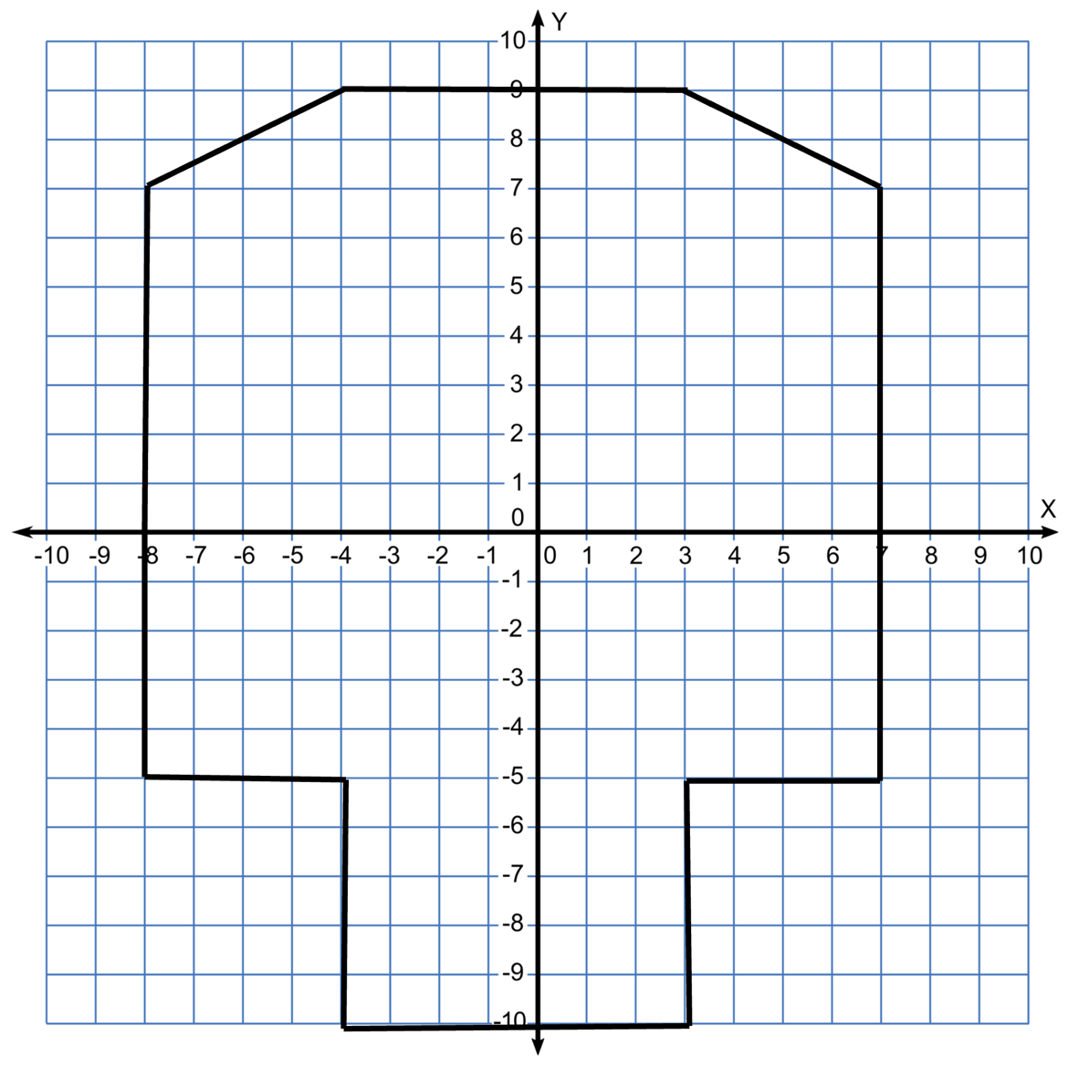
[A: 3-4, iii]
Starting the Rescue Mission

As you step out of the basement room, you also find a piece of paper on the floor with the following writings:
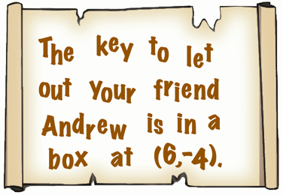
- Plot and label the location of the box on the map above. Then, from the list of numbers provided in the red box, select the correct number for each blank space in the description below to describe the way in which you can get to the box mentioned in the writings above. Use a ruler to draw this move on the map provided.

Description |  | List
“From your location at $\left(1,-6\right)$, walk ___________ units up in the positive $y$ direction. Then, turn right and walk ___________ units right in the positive $x$ direction. Then you will reach the box at $\left(6,-4\right)$.” |  | $$-4$$ | $$2$$ | $$4$$
 |  | $$-2$$ | $$-5$$ | $$5$$
[A: 5-6, i-iii]

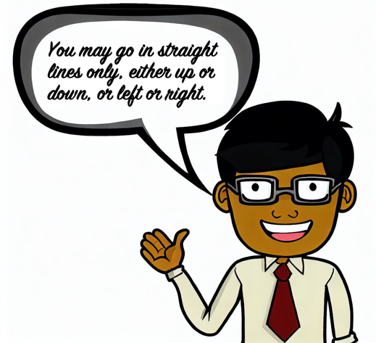
Now that you’re at $\left(6,-4\right)$, you found the key that lets your friend Andrew free.
- Use the description in question (4) as an example to describe the way that allows you to go from your location at $\left(6,-4\right)$ to Andrew’s location at $\left(❤️,🔆\right)$. Then, use a ruler to draw this move on the map provided in question (3) above.

[A: 5-6, ii-iii]

From Andrew location at $\left(❤️,🔆\right)$, you accidentally go two units up, at which point you fall through a hole that slides you to the location with coordinates $\left(-3,-7\right)$.
- Plot and label the location of the hole and the location to which you slide. Then, from the descriptions below, select what best describes this slide.

This move may be described as…
(a) |  | … being reflected over the $x$-axis.
(b) |  | … being reflected over the $y$-axis.
(c) |  | … neither (a) nor (b).
[A: 5-6, ii-iii]

Completing the Rescue

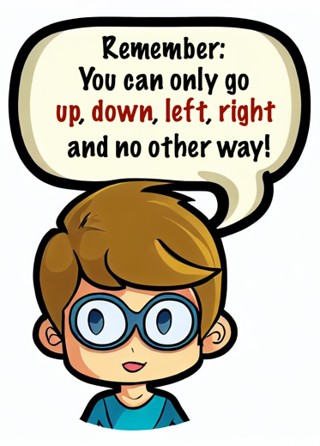
- Use the description in question (4) as an example to describe the way that allows you to go
  - from your current location at $\left(-3,-7\right)$ to Brigitte’s location at $\left(🟣,-🟦\right)$.

  - Then, from Brigitte’s location to Christian’s location at $\left(-🔶,☘️\right)$.

  - Then, use a ruler to draw both of these moves on the map provided in question (3) above.
[A: 7-8, ii-iii]

From Christian’s location at $\left(-🔶,☘️\right)$, you and your friends with you start moving to the right. After moving 3 units, you find another note that shows the following description of a portal:

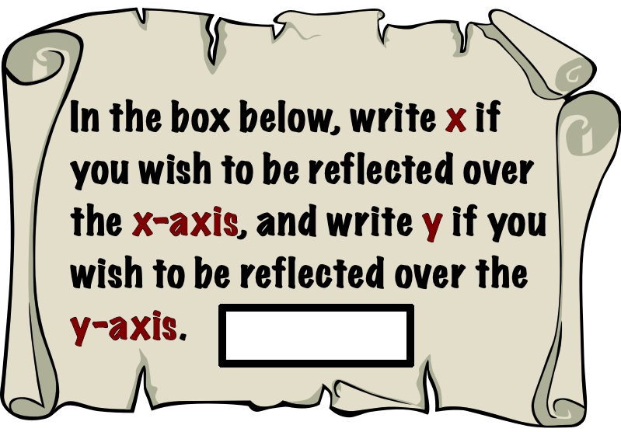

  - Determine which reflection would take you and your friends closer to Danielle, whose location is at $\left(☘️,-❤️\right)$. Write down your choice in the box above.
  - Then, on the graph above, plot and label the point where you find yourself after this reflection and write down the coordinates of both the starting point and the ending point of this portal.

  - Then, describe the way that allows you to go to Danielle’s location from the ending point of that portal.

  - Then, use a ruler to draw this move on the map provided in question (3) above.
[A: 7-8, i-iii]

The Final Escape

Now that you and all your friends are together at this final location at $\left(☘️,-❤️\right)$, there is only one more thing to do: to find the exit through which you all can escape from this Haunted Mansion.

  - Select and apply the appropriate method to find the value of the $x$ and $y$-coordinates by solving the expressions shown below.

$x$-coordinate:

$$\frac{☘️×\left(🟦-🟣\right)+🔶}{❤️}+\frac{🔆×\left(🔆-🟦\right)+\left(🟣÷❤️\right)}{☘️}=$$

$y$-coordinate:

$$🟣+❤️+🔆×☘️+\left(\frac{❤️}{☘️}×\left(🔶-❤️\right)\right)÷🔆=$$

  - Then, plot and label this exit point on the map provided in question (3).
  - Then, describe your movement to get to that point.

[A: 7-8, i-iii]

